**PPS Mini Project**

**2021-2022**

**Name: Meheraab Chothia**

**Registration No.:RA2111003011332**

**Title: Connect 4**

**Connect 4**

**Problem Statement:** Creation of the popular game Connect 4(also called 4 in a row). Two players will play the game against each other. Both of them will take turns to choose a row and place their tokens in the row. Whoever manages to connect 4 of their tokens in a row in any direction will win hence the name connect 4.

**Input and Output:** The program will constantly ask the users for their inputs and will print the entire board with a change based on the choice of the user.

Example:

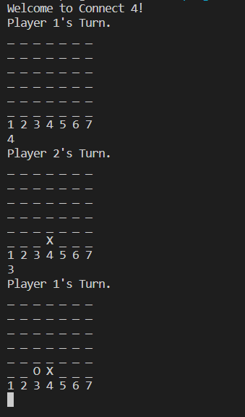

As shown in the picture above when the user chooses a row the output of the board will have their choice printed along with it. This will continue until there are no more open spaces or one of the 2 players manages to win.

**Program:**

#include<stdio.h>

#include<conio.h>

#include<stdlib.h>

char board[100][100];

int i,j,h=6,w=7,turns=0;

char pce,p1='X',p2='O';

int k[100];

void Start()

{

    for(i=0;i<w;i++)

    {

        k[i]=5;

    }

    for(int i=0;i<h;i++)

    {

        for(int j=0;j<w;j++)

        {

            board[i][j]='_';

        }

    }

}

void Board()

{

    for(int i=0;i<h;i++)

    {

        for(int j=0;j<w;j++)

        {

            printf("%c ",board[i][j]);

        }

        printf("\n");

    }

    for(int i=1;i<=w;i++)

    {

        printf("%d ",i);

    }

    printf("\n");

}

int wcheck(int x,int y,char tok)

{

    int count=0,t1,t2;

    //horizontal

    t1=y+1;count=0;

    while(t1<w && board[x][t1]==tok)

    {

        count++;

        t1++;

    }

    t1=y-1;

    while(t1>=0 && board[x][t1]==tok)

    {

        count++;

        t1--;

    }

    if(count>=3)

        return 1;

    //vertical

    t1=x+1;count=0;

    while(t1<h && board[t1][y]==tok)

    {

        count++;

        t1++;

    }

    t1=x-1;

    while(t1>=0 && board[t1][y]==tok)

    {

        count++;

        t1--;

    }

    if(count>=3)

        return 1;

    //first diagonal

    t1=x+1;t2=y+1;count=0;

    while(t1<h && t2<w && board[t1][t2]==tok)

    {

        count++;

        t1++;t2++;

    }

    t1=x-1;t2=y-1;

    while(t1>=0 && t2>=0 && board[t1][t2]==tok)

    {

        count++;

        t1--;t2--;

    }

    if(count>=3)

        return 1;

    //second diagonal

    t1=x-1;t2=y+1;count=0;

    while(t1>=0 && t2<w  && board[t1][t2]==tok)

    {

        count++;

        t1--;t2++;

    }

    t1=x+1;t2=y-1;

    while(t1<h && t2>=0 && board[t1][t2]==tok)

    {

        count++;

        t1++;t2--;

    }

    if(count>=3)

        return 1;

    else

        return 0;

}

void Input()

{

    int g_o=0,one,two,row,r,c;

    while(g_o==0)

    {

        if(turns%2==0)

        {

            printf("Player 1's Turn.\n");

            Board();

            scanf("%d",&one);

            if(one>0 && one<=w && k[one-1]>=0)

            {

                row=k[one-1];

                board[row][one-1]=p1;

                k[one-1]--;

                r=row;c=one-1;

                turns++;

                pce=p1;

            }

            else

            {

                printf("Invalid input try again.\n");

                continue;

            }

        }

        else

        {

            printf("Player 2's Turn.\n");

            Board();

            scanf("%d",&two);

            if(two>0 && two<=w && k[two-1]>=0)

            {

                row=k[two-1];

                board[row][two-1]=p2;

                k[two-1]--;

                r=row;c=two-1;

                turns++;

                pce=p2;

            }

            else

            {

                printf("Invlaid input try again.\n");

                continue;

            }

        }

        if(wcheck(r,c,pce)==1)

        {

            g_o=1;

            Board();

        }

    }

}

int main()

{

    while(true)

    {

        int y_n=0;

        printf("Welcome to Connect 4!\n");

        Start();

        Input();

        if(turns==h*w)

        {

            printf("It's a Draw you both suck!\n");

        }

        else if(pce=='O')

        {

            printf("Player 2 Wins!\n");

        }

        else if(pce=='X')

        {

            printf("Player 1 Wins!\n");

        }

        printf("Would you like to play again? 1 or 0\n");

        scanf("%d",&y_n);

        if(y_n!=1)

        {

            printf("Goodbye!\n");

            break;

        }

        else{

            printf("\nPlaying again!\n");

        }

    }

    getch();

    return 0;

}

**Output:**

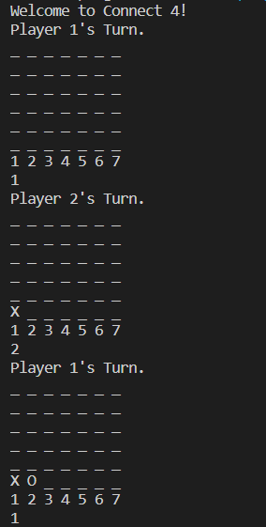

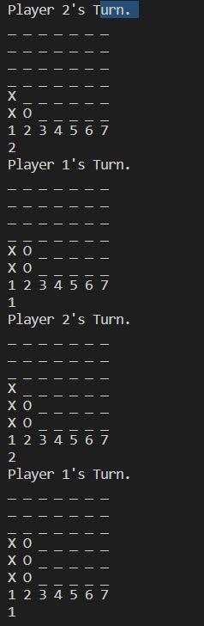

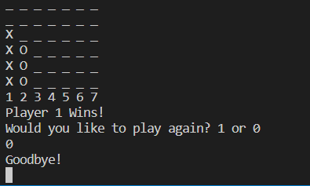

**Result:**

The problem statement was converted into a program and was executed successfully.